**Stored Procedures**

**Scenario 1:** The bank needs to process monthly interest for all savings accounts.

CREATE TABLE accounts (

account_id NUMBER PRIMARY KEY,

account_type VARCHAR2(20),

balance NUMBER(12,2)

);

CREATE TABLE employees (

emp_id NUMBER PRIMARY KEY,

name VARCHAR2(50),

department_id NUMBER,

salary NUMBER(12,2)

);

INSERT INTO accounts VALUES (1, 'SAVINGS', 5000);

INSERT INTO accounts VALUES (2, 'SAVINGS', 10000);

INSERT INTO accounts VALUES (3, 'CHECKING', 7500);

INSERT INTO accounts VALUES (4, 'SAVINGS', 2500);

INSERT INTO employees VALUES (1, 'Alice', 10, 50000);

INSERT INTO employees VALUES (2, 'Bob', 20, 60000);

INSERT INTO employees VALUES (3, 'Carol', 10, 55000);

COMMIT;

BEGIN

UPDATE accounts

SET balance = ROUND(balance * 1.01, 2)

WHERE account_type = 'SAVINGS';

DBMS_OUTPUT.PUT_LINE(SQL%ROWCOUNT || ' savings accounts credited with 1% interest.');

COMMIT;

END;

/

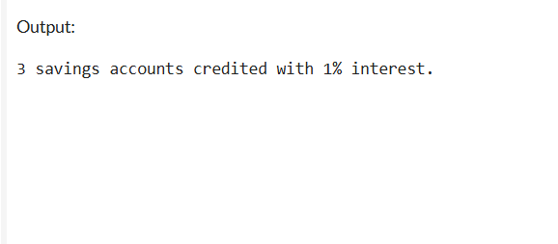

**Scenario 2:** The bank wants to implement a bonus scheme for employees based on their performance.

CREATE TABLE employees (

emp_id NUMBER PRIMARY KEY,

name VARCHAR2(50),

department_id NUMBER,

salary NUMBER(12,2)

);

INSERT INTO employees VALUES (1, 'Alice', 10, 50000);

INSERT INTO employees VALUES (2, 'Bob', 20, 60000);

INSERT INTO employees VALUES (3, 'Carol', 10, 55000);

COMMIT;

DECLARE

p_dept_id NUMBER := 10; -- Department to apply bonus

p_bonus_pct NUMBER := 10; -- Bonus percentage

BEGIN

UPDATE employees

SET salary = ROUND(salary * (1 + p_bonus_pct / 100), 2)

WHERE department_id = p_dept_id;

DBMS_OUTPUT.PUT_LINE(SQL%ROWCOUNT || ' employees in department ' ||

p_dept_id || ' received a ' || p_bonus_pct || '% bonus.');

COMMIT;

END;

/

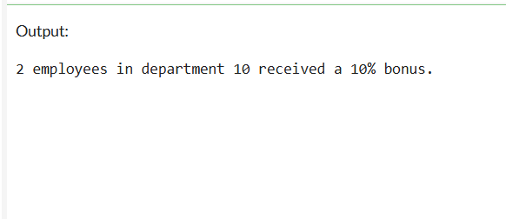

**Scenario 3:** Customers should be able to transfer funds between their accounts.

CREATE TABLE accounts (

account_id NUMBER PRIMARY KEY,

account_type VARCHAR2(20),

balance NUMBER(12,2)

);

INSERT INTO accounts VALUES (1, 'SAVINGS', 5000);

INSERT INTO accounts VALUES (2, 'SAVINGS', 8000);

INSERT INTO accounts VALUES (3, 'CHECKING', 3000);

COMMIT;

CREATE OR REPLACE PROCEDURE TransferFunds (

p_from_acct IN NUMBER,

p_to_acct IN NUMBER,

p_amount IN NUMBER

) IS

v_balance accounts.balance%TYPE;

BEGIN

SELECT balance INTO v_balance

FROM accounts

WHERE account_id = p_from_acct

FOR UPDATE;

IF v_balance < p_amount THEN

RAISE_APPLICATION_ERROR(-20001,

'Insufficient funds in account ' || p_from_acct);

END IF;

UPDATE accounts

SET balance = balance - p_amount

WHERE account_id = p_from_acct;

UPDATE accounts

SET balance = balance + p_amount

WHERE account_id = p_to_acct;

COMMIT;

DBMS_OUTPUT.PUT_LINE(

'Transferred ' || p_amount ||

' from account ' || p_from_acct ||

' to account ' || p_to_acct

);

EXCEPTION

WHEN NO_DATA_FOUND THEN

RAISE_APPLICATION_ERROR(-20002,

'One or both accounts not found.');

WHEN OTHERS THEN

ROLLBACK;

RAISE;

END TransferFunds;

/

BEGIN

TransferFunds(1, 2, 1500);

END;

/

SELECT * FROM accounts ORDER BY account_id;

